MIDTERM EXAMINATION
Spring 2009
MTH601- Operations Research
Time: 60 min
Marks: 40
Student Info
Student ID:
Center:
Exam Date:

For Teacher's Use Only
Q No. | 1 | 2 | 3 | 4 | 5 | 6 | 7 | 8 | Total
Marks
Q No. | 9 | 10 | 11 | 12 | 13 | 14 | 15 | 16
Marks
Q No. | 17 | 18 | 19 | 20 | 21 | 22 | 23 | 24
Marks

Question No: 1 ( Marks: 1 ) - Please choose one

EST and EFT of activities are calculated in

► Forward pass

► Backward pass

► Path does not effected

Question No: 2 ( Marks: 1 ) - Please choose one

_________________ may be less than most likely time estimate

► Pessimistic time estimate

► Smallest time estimate

► Optimistic Time estimate

Question No: 3 ( Marks: 1 ) - Please choose one

The dummy activities consume

► No time, no resources

► No time but some resources

► Some resources in minimum time

► None of these

Question No: 4 ( Marks: 1 ) - Please choose one

If an activity consumes no time and no resources then this activity is called __________.

► dummy activity

► sequential activity

► critical activity

► cyclic activity

Question No: 5 ( Marks: 1 ) - Please choose one

Cost period-------( No of ordered items)

► Holding cost

► Set up cost

► Stock out cost

► Item cost

Question No: 6 ( Marks: 1 ) - Please choose one

The following network is an example of
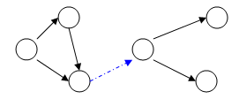

► Redundancy

► Cycling

► Looping

► Merging

Question No: 7 ( Marks: 1 ) - Please choose one

The following network is an example of
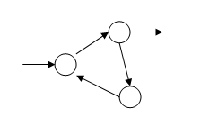

► Redundancy

► Dangling

► Cycling

► Dummy

Question No: 8 ( Marks: 1 ) - Please choose one

Which one is best describe Micro Economic Planning?

► Distribution of fertilizer

► Improving the layout of a workshop in a company

► Investment planning of the country

► PERT

Question No: 9 ( Marks: 1 ) - Please choose one

If t₀ = 6, t_{m} = 12 and t_{p} = 18, then V_{t}= _________

► 12

► 2

► 4

► 144

Question No: 10 ( Marks: 1 ) - Please choose one

Which inventory model also known as a saw tooth model?

► Purchasing Model with no shortages

► Purchasing Model with shortages

► Manufacturing Model with no shortages

► Manufacturing Model with shortages

Question No: 11 ( Marks: 1 ) - Please choose one

For backward pass computations

► Earliest start timeLatest start time

► Earliest start timeLatest start time

► Earliest start timeLatest start time = 0

► Earliest start timeLatest start time

Question No: 12 ( Marks: 1 ) - Please choose one

For an activity if optimistic time, most likely time estimate and pessimistic time estimate are 3, 6 and 15 respectively then expected time is

► 4

► 3

► 7

► 20

Question No: 13 ( Marks: 1 ) - Please choose one

In a quadratic programming problem unlike linear programming problem

► Only objective function is quadratic

► Both objective function and constraints are quadratic

► Only constraints are quadratic

► At least one of objective function or constraint must be quadratic

Question No: 14 ( Marks: 1 ) - Please choose one

Solution region of the constraint 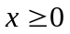 is

► Half plane to the right of straight line 

► Half plane to the right of y-axis

► Half plane to the region where abscissas are non-negative

► All are equivalent

Question No: 15 ( Marks: 1 ) - Please choose one

A dummy activity is a simulated activity of sorts, one that is of ________duration and is created for the sole purpose of demonstrating a specific relationship and path of action on the arrow diagramming method.

► Zero

► Minimum

► Maximum

► Average

Question No: 16 ( Marks: 1 ) - Please choose one

Activity definition refers to the process of parsing a project into a number of individual tasks which must be completed ___________ the deliverables can be considered completed. Activity definitions rely on a number of specific input processes.

► before

► both before and after

► after

Question No: 17 ( Marks: 1 ) - Please choose one

A forward pass is used to determine and calculate the ________________ dates, through utilization of a previously specified start date.

► early start and early finish

► late start and early finish

► early start and late finish

► late start and late finish

Question No: 18 ( Marks: 1 ) - Please choose one

Is this Network legal?
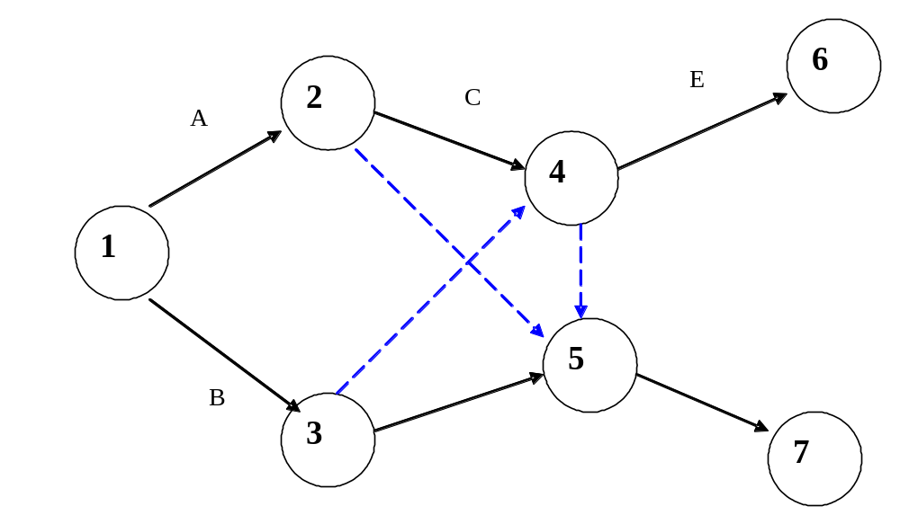

► Yes.

► No.

Question No: 19 ( Marks: 1 ) - Please choose one

Total cost per period = Item cost + Order cost + Holding cost + _____________.

► Shortage cost

► Optimum Shortage (S*)

► Economic Oreder Quantity. (Q*)

► Maximum Inventory. (I _{max}.)

Question No: 20 ( Marks: 1 ) - Please choose one

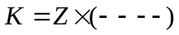
Where K is called service factor.

► 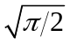

► 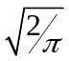

► 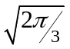

► 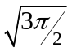

Question No: 21 ( Marks: 2 )

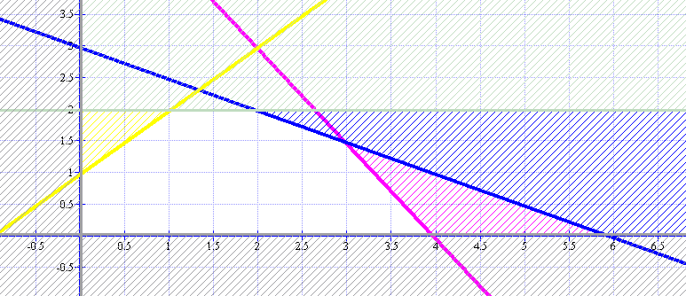

Using above graph, Write down the equation (Blue shaded area).

Question No: 22 ( Marks: 3 )

Draw a net work diagram for the following dependency relationship.
A controls F, G and H; B controls G and H with H controlled by C.

Question No: 23 ( Marks: 5 )

Draw the graph of the following constraints.

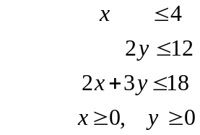

Question No: 24 ( Marks: 10 )

Solve by Graphical method:
Shows corner points and optimize the objective function.



